The Home School Compact is a written agreement between the school, parents, and students. It is jointly developed with input from students, parents, and school staff, and outlines how each will share in the responsibility for improved student academic achievement and how the school and the parents will build a partnership that will help children achieve the state’s high standards. ESSA, Section 1116(d)
Shared  Responsibilities for: | School Staff  This Photo by Unknown Author is licensed under CC BY-NC  As a School we will: | Parent/Caregiver  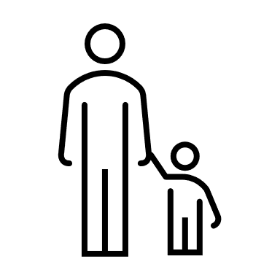  As a parent/caregiver, I will: | Student  This Photo by Unknown Author is licensed under CC BY-SA-NC  As a student, I will:
High Quality Curriculum and Instruction  ESSA, Section  1116(d)(1) | - Review assessment results to determine strengths and needs  - Use the BCPS curriculum to plan high quality instruction that will improve students’ academic performance  - Give students timely feedback | - Talk to my child about what is happening at school and the importance of working hard in school  - Make sure my child goes to school every day on time  - Make sure my child does homework and schoolwork regularly | - Do my best and work hard  - Come to school on time and prepared to learn  - Pay attention in class and ask questions when I don’t understand  - Complete all my assignments  - Follow the rules of the school
Parent-Teacher Conferences  ESSA, Section 1116(d)(2)(C | - Hold at least one parent/teacher conference annually, where Home School Compact and student achievement is discussed  - Provide multiple opportunities for parents to be involved including family engagement events, student achievement meetings, volunteering | - Attend parent/teacher conferences to be aware of my child’s progress and to communicate with the teacher | - Know what is expected of me in all subjects  - Talk to my family about things I am learning in school
Communication/ Frequent Reports  ESSA, Section 1116(d)(2)(B) | - Communicate with families about high academic standards, student progress and the school’s overall performance | - As much as possible I will attend school events, workshops, and conferences to learn how to best support my child’s learning | - Copy assignments into my planner and show my family every day  - Check my grades with my family  - Ask my teacher for help when I have problems with my schoolwork/homework
Accessibility  ESSA, Section 1116(d)(2)(C) | - Communicate with families in a language they understand when possible  - Offer meetings at various times  - Utilize a variety of outreach methods | - Attend PTA meetings, parent trainings, and other activities  - Ensure that the school will be able to reach me  - Choose a preferred method of outreach | - Help other students  - Respect all students and adults.  - Be kind
Communication  ESSA, Section 1116(d)(2)(D) | - Maintain meaningful two way communication that is ongoing with families through notes, phone calls, school messenger, etc.  - We will be available to meet with parents upon request and as schedules permit | - Communicate frequently with my child’s teacher through notes, phone calls and conferences. I will access school website and Schoology. | - Be responsible to share papers with caregivers regarding conferences, family workshops, and my academic progress  - Appropriately voice my concerns and opinions about our classroom environment

